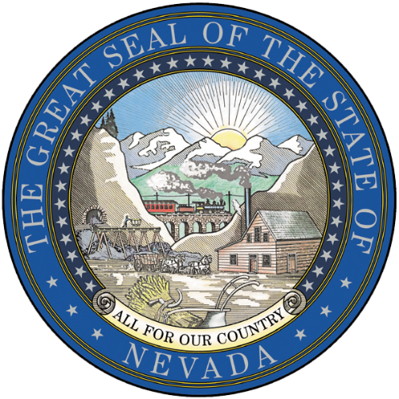

DRAFT (50%) Nevada PFAS Action Plan

Table of Contents
1. Introduction 2
2. PFAS in Nevada 3
3. PFAS in other States 6
4. PFAS at the Federal Level 6
5. Outreach and Communication Plan 8
6. Analytical Methods and Procedures 8
7. Treatment Technologies 8
8. References 9

Introduction
Per- and polyfluoroalkyl substances (PFAS) are a class of emerging contaminants consisting of fluorinated compounds that are more than several thousand chemicals. Due to the widespread use of some PFAS in consumer and commercial applications including firefighting foams and stain repellants for clothing and carpets, these chemicals are being detected in drinking water supplies, groundwater, surface water, landfill leachate, and air. Due to laboratory and epidemiological studies by federal health and environmental agencies, the U.S. Environmental Protection Agency (EPA) issued a Lifetime Health Advisory for perfluorooctanoic acid (PFOA) and perfluorooctane sulfonic acid (PFOS) established at 70 parts per trillion (ppt) in 2016. EPA also published a PFAS Strategic Roadmap in 2021, which will likely result in further actions from federal regulatory agencies.
Assembly Bill (AB) 97 that was passed in 2021 called for the establishment of a working group to study issues relating to environmental contamination resulting from PFAS in Nevada. The Nevada Division of Environmental Protection (NDEP) addressed this requirement through the development of a Working Group composed of representatives of interested state and local public agencies, labor organizations, community organizations and trade associations to support the development of the PFAS Action Plan for the State of Nevada. The purpose of the working group and Nevada PFAS Action Plan was to:
- Evaluate the potential for environmental contamination in the State resulting from PFAS
- Determine the location and extent of potentially significant discharges or releases of PFAS in the State
- Compile information relating to existing federal, State and local actions and identify data gaps to monitor, contain and clean up environmental contamination resulting from PFAS
- Determine the potential points of exposure to PFAS for residents of the State
- Develop recommendations for state and local action to prevent releases, monitor drinking water sources, and contain and clean up environmental contamination resulting from PFAS

This document serves as the State of Nevada PFAS Action Plan with input from the PFAS Working Group and other stakeholders in an effort to create consistent, concise, and collaborative approaches focused on addressing PFAS in Nevada.

PFAS in Nevada
- Current Data Points
  - Third Unregulated Contaminant Monitoring Rule (UCMR3): 2013 – 2015
UCMR3 was published on May 2, 2012 requiring the monitoring for 30 contaminants (28 chemicals and two viruses) between 2013 and 2015 using analytical methods developed by EPA, consensus organizations or both. Public water systems (PWSs) or EPA conducted sampling and analysis for assessment monitoring, screening survey, and pre-screen testing contaminants. The following PFAS were analyzed during the assessment monitoring with corresponding minimum reporting limits: perfluorooctanesulfonic acid (PFOS) 0.04 microgram per liter (µg/L), perfluorooctanoic acid (PFOA) 0.02 µg/L, perfluorobutanesulfonic acid (PFBS) 0.09 µg/L, perfluorohexanesulfonic acid (PFHxS) 0.03 µg/L, perfluoroheptanoic acid (PFHpA) 0.01 µg/L, and perfluorononanoic acid (PFNA) 0.02 µg/L.
The following public water systems (PWSs) were sampled in the state of Nevada: Boulder City, City of Elko, Carson City Public Works, City of Henderson, Dayton Valley Water System, Double Diamond, Edgewood Water Company, Ely Municipal Water Department, Escapee Co-op of NV, Fernley Public Works, Gardnerville Ranchos GID, Las Vegas Valley Water District, North Las Vegas Utilities, Round Mountain PUC, South Truckee Meadows GID, Sun Valley GID, Truckee Meadows Water Authority, and Virgin Valley Water District. All PFAS results from all PWSs were below the minimum reporting limits (https://www.epa.gov/dwucmr/occurrence-data-unregulated-contaminant-monitoring-rule#3).
  - Desert Research Institute Study
A study from researchers at the Desert Research Institute (X. Bai, Y. Son; 2021) evaluated surface water and sediments collected from six locations along the Las Vegas Wash and Lake Mead and eight locations along the Truckee River, Lake Tahoe, and Pyramid Lake in Nevada. Of the 17 perfluoroalkyl substances analyzed, 12 were detected in the surface water and 14 were detected in the sediments. The total concentration of perfluoroalkyl substances in the Truckee River was 441.7 nanograms per liter (ng/L) and in Las Vegas Wash water was 2234.3 ng/L. The predominant compounds found in the water were perﬂuorohexanoic acid (PFHxA) (1.5 – 187.0 ng/L), followed by perﬂuoropentanoic acid (PFPeA) (below detection limit [BDL] to 169.9 ng/L), PFOA (BDL to 65.5 ng/L), and PFBS (BDL to 44.7 ng/L). Concentrations of perfluoroalkyl substances in the sediments was 272.9 microgram per kilogram (μg/kg) for the Truckee River and 345.7 μg/kg for the Las Vegas Wash. The predominant species in the sediments were perﬂuorodecane sulfonic acid (PFDS) (BDL to 88.2 μg/kg), PFHxA (BDL to 20.3 μg/kg), PFBS (BDL to 29.1 μg/kg), and perﬂuoroundecanoic acid (PFUA) (BDL to 22.9 μg/kg). The Las Vegas Wash water resulted in higher levels compared with the Truckee River water. Concentrations and detection frequencies signiﬁcantly decreased in summer compared with winter along the Las Vegas Wash.

  - Department of Defense Sampling Data
- Potential Location of Releases
  - Land Application of Biosolids
  - Wastewater Treatment Plants
- Sources of Exposure
Surface Water
Groundwater
Drinking Water
  - Public Water Systems
  - Domestic Wells
There is limited tracking of historical PFAS use in Nevada and limited environmental monitoring data. Therefore, the locations of facilities that are potentially associated with PFAS materials as identified in the Association of State Drinking Water Administrators (ASDWA) guidance (ASDWA, Mapping Guide for Per- and Polyfluoroalkyl Substances (PFAS) Source Water Assessments, Appendix A) are being used to help inform where PFAS might be present in the environment. Details on the evaluation are based on the following available information:
Facilities by NAICS Code
- All facilities with North American Industry Classification System (NAICS) Codes in ASDWA guidance from EPA facility registry system (FRS) database
- Large Quantity Hazardous Waste Generators with NAICS Codes in ASDWA guidance from EPA FRS database
- Facilities having air quality operating permits (AQOPs) with NAICS Codes in ASDWA guidance from NDEP database
Facilities From NDEP databases
- Landfills from NDEP database
- POTWs from NDEP database
- Military bases and other Airports
- Other facilities (firefighter training, etc.)
- Future Actions
NDEP has utilized a drinking water source ranking assessment GIS tool to conduct a preliminary PFAS screening on drinking water protection areas (DWPA) within Nevada. The tool uses several input GIS feature classes, a python script to prepare the DWPA feature class on which the assessment is run, and SQL Server database views to calculate a sample prioritization score for each DWPA. By using available geodatabases to develop State-wide maps, potential risk locations for exposure related to drinking water sources can be identified. The sampling tool will serve as an initial approach for this screening level evaluation. Drinking water sources are being identified that supply regulated public water systems. This is a screening level approach and detailed information is not available for analysis of exposure pathways.
Additional considerations may be given to address locations in the State that rely on private domestic wells for drinking water.
Developing a routine monitoring strategy based on the potential risks identified will ensure exposure to PFAS will be minimized through drinking water sources. The following items are planned actions that will support efforts to characterize the extent of PFAS contamination in Nevada.

- Grant funding from EPA for Drinking Water & Environmental Sampling
  - Small Amount for targeted/voluntary sampling
  - Begin Contract in 2nd Half 2022
- UCMR5

The fifth Unregulated Contaminant Monitoring Rule (UCMR 5) published on December 27, 2021 requires sample collection for 30 chemical contaminants between 2023 and 2025 using analytical methods developed by EPA and consensus organizations. All PWSs serving more than 10,000 people, all serving 3,300 to 10,000 people, and 800 representative PWSs serving fewer than 3,300 people will be monitored. UCMR5 will provide new data that is needed to improve overall understanding of the frequency that 29 PFAS are found in drinking water systems with corresponding levels. The EPA continues to be responsible for all analytical costs associated with monitoring at systems serving 10,000 or fewer. More information on the monitoring scope can be found at the Agency’s website.

The results from the mentioned sampling and monitoring strategies will be compared to the current USEPA’s Health Advisory Levels (HALs). If drinking water sources are impacted above the HALs, additional actions will be considered…
a.
b.

- Action items for PFAS exceedances, including investigative and clean-up activities…
- Basic Comparison Levels (BCLs)
The NDEP Basic Comparison Levels (BCLs) address human health exposure pathways. The comparison of site characterization data against risk-based media concentrations provide for an initial screening evaluation to assist users in risk assessment components such as the evaluation of data usability, determination of extent of contamination, identification of chemicals of potential concern, and identification of preliminary remediation goals. The BCLs for PFOA and PFOS are 0.667 µg/L in addition to PFBS at 667 µg/L. As mentioned in the “User’s Guide and Background Technical Document for the Nevada Division of Environmental Protection Basic Comparison Levels for Human Health for the BMI Complex and Common Areas” from 2017, the BCLs for PFOA and PFOS were derived using the toxicity criteria utilized by the USEPA USEPA (2016a, b) to develop drinking water health advisories for these two chemicals was used. For PFOA, the oral cancer slope factor of 0.07 (mg/kg-day)⁻¹ and the reference dose (RfD) of 0.00002 mg/kg-day were used. The International Agency for Research on Cancer (IARC) classifies PFOA as being possibly carcinogenic to humans (Group 2B). The oral slope factor is based on a rat study by Butenhoff et al. (2012) that found an increased incidence in testicular Leydig cell tumors in rats. The RfD is based on developmental effects in mice from Lau et al. (2006). For PFOS, the RfD of 0.00002 mg/kg-day based on developmental effects in rats from a study by Luebker et al. (2005).
These BCLs are designed for use at the BMI Complex and Common Areas in Henderson, Nevada.
- The applicability of the BCLs should be verified prior to use at any other site.

The guidance provided for the PFAS BCLs is not final NDEP action. It is neither intended to nor can it be relied upon, to create any rights enforceable by a party in litigation with the state of Nevada.

PFAS in other States
Other States near Nevada and across the US are addressing PFAS related issues. Some of these States have historical PFAS manufacturing and use leading to elevated levels of environmental contamination. Furthermore, some States have established maximum contaminant levels (MCLs) for PFAS in addition to guidance values for groundwater and surface water. More information on the specific actions taken by the other States is available elsewhere including the Environmental Council of States (ECOS) and USEPA.
Some states have regulatory programs for PFAS with different priorities, guidelines, and overall focus. California, under Proposition 65, listed PFOS and PFOA as potential developmental (reproductive) toxicants. This listing has labeling requirements for manufacturers, distributors, and retailers of consumer products in addition to prohibiting companies from discharging PFOA or PFOS to sources of drinking water if the discharges would result in exposures that exceed a health-based level. Other States including Vermont, New York, New Jersey, Colorado, and Alaska have formal regulations on perfluoroalkyl acids (PFAAs) as hazardous substances (ITRC 2021).
Chemical Management and Safer States (https://www.saferstates.org/vision/):

PFAS at the Federal Level
The EPA Council on PFAS developed a strategic roadmap to lay out the EPA’s whole-of-agency approach to address these emerging contaminants. The roadmap sets timelines by which the Agency plans to take specific actions between 2021 and 2024 building upon the policy actions identified in the Agency’s 2019 action plan. A preliminary rule is anticipated by the end of 2022 with a final rule promulgated in the fall of 2023. EPA’s integrated approach to PFAS is on three main directives:
- Research – Invest in research, development, and innovation to better understand PFAS exposures and toxicities, human health and ecological effects, and effective interventions that incorporate the best available science.
- Restrict – Comprehensive approach to prevent PFAS entering the environment at levels that can adversely impact human health and the environment.
- Remediate – Broaden and accelerate the cleanup of PFAS contamination.
More details related to the EPA’s roadmap are found in Figure 1 and at the Agency’s website.

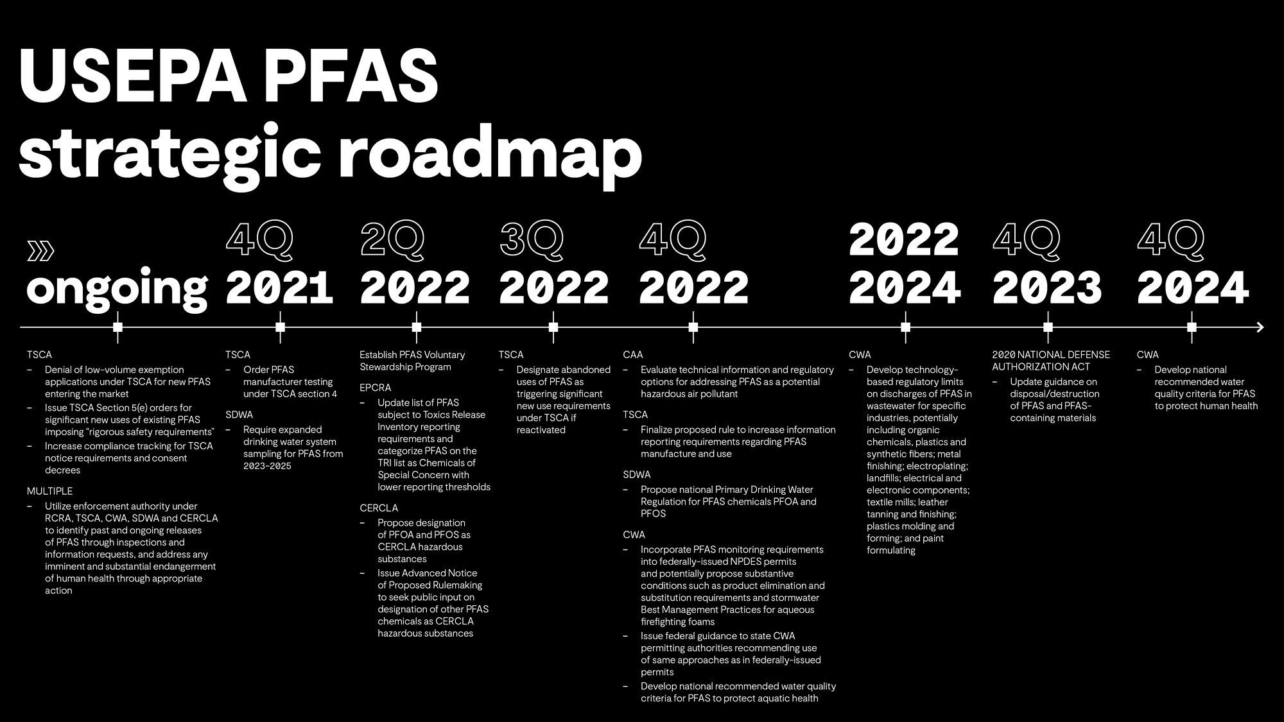

Figure 1 USEPA’s Strategic Roadmap

Outreach and Communication Plan
The most effective risk communication strategies employ a combination of techniques that build trust and demonstrate a partnership with the community through clear science communication that is accessible, factual, and transparent. The dynamic considerations related to communicating PFAS challenges to concerned citizens, the regulated community, and other stakeholders are important to NDEP for transparency and collaboration within the State of Nevada. All updates related to this action plan, communication related to impacted drinking water sources, and tools for water system operators for public notice will be made available via NDEP’s website, http://ndep.nv.gov/water/pfas-action-plan.

Analytical Methods and Procedures
Analytical methods for PFAS detection, identification, and quantitation continue to be revised as improvements are made to sample preparation and instrumentation techniques. At present, the USEPA has two multi-laboratory validated methods specifically for drinking water samples. EPA Method 533 focuses on short-chain PFAS including perfluorinated acids, sulfonates, fluorotelomers, and poly/perfluorinated ether carboxylic acids. EPA Method 537.1 focuses on the PFAS that have the potential to contaminate drinking water that have been identified or introduced as PFOA/PFOS alternatives such as HFPO-DA (component of GenX processing aid technology). Draft Method 1633 is currently a single-laboratory validated method for 40 PFAS in wastewater, surface water, groundwater, soil, biosolids, sediment, landfill leachate, and fish tissue. This draft method is being developed in collaboration with USEPA and the Department of Defense. A multi-laboratory validation study will be conducted by DoD with the EPA.
Other PFAS and fluorine methods are in different stages of development such as Method 8327 for aqueous and solid samples, Other Test Method (OTM)-45 for source air emissions, total organic fluorine as a screening tool to identify PFAS absence and presence. More information on all of the analytical methods is available at the Agency’s website. Furthermore, practical comparisons of the available methods have been performed by the Interstate Technology and Regulatory Council’s (ITRC’s) PFAS team is available in the current technical guidance document.

Treatment Technologies
Treatment technologies for PFAS-impacted matrices including soil and water are still evolving. Remedial alternatives are being prioritized based on the overall protection of drinking water supplies, reduction of risk to sensitive receptors such as ecological receptors and environmental resources, and reduction of source area mass.

At this point, a variety of treatment technologies are available at different stages of implementation. The field-implemented technologies that are demonstrated at full-scale for liquids are sorption technologies such as granular activated carbon and ion exchange resin. Additionally, reverse osmosis that pushes water under pressure through a semipermeable membrane has been demonstrated at full-scale for PFAS removal.

The field-implemented technologies that are demonstrated at full-scale for solids is sorption followed by stabilization to reduce the potential for PFAS to leach from the material and excavation with disposal to permitted landfills.

Other treatment technologies are available including limited application and developing technologies for liquids and solids. Practical comparisons of the available technologies are found within the ITRC’s PFAS Team technical guidance document.

References

Bai, X., Son, Y. 2021. Perﬂuoroalkyl substances (PFAS) in surface water and sediments from
two urban watersheds in Nevada, USA. Science of the Total Environment 751: 141622.

Butenhoff, J.L., G.L. Kennedy, Jr., S.C. Chang, and G.W. Olsen. 2012. Chronic dietary toxicity and carcinogenicity study with ammonium perfluorooctanoate in Sprague-Dawley rats.Toxicology 298:1–13.

Lau, C., J.R. Thibodeaux, R.G. Hanson, M.G. Narotsky, J.M. Rogers, A.B. Lindstrom, and
M.J. Strynar. 2006. Effects of perfluorooctanoic acid exposure during pregnancy in the mouse.
Toxicological Science 90:510–518.

Luebker, D.J., R.G. York, K.J. Hansen, J.A. Moore, and J.L. Butenhoff. 2005. Neonatal mortality from in utero exposure to perfluorooctanesulfonate (PFOS) in Sprague-Dawley rats: dose-response and biochemical and pharmacokinetic parameters. Toxicology 215:149–169.

USEPA, 2016a. Drinking Water Health Advisory for Perfluorooctanoic Acid (PFOA). EPA 822-
R-16-005. Office of Water, Washington DC. May.

USEPA, 2016b. Drinking Water Health Advisory for Perfluorooctane Sulfonate (PFOS). EPA
822-R-16-004. Office of Water, Washington DC. May.

