319(h) Pre-Application
Primary Contact Person:
Project Title:

Lead Agency Organization:

Contact Person’s Email Address:
Contact Person’s Mailing Address:
City
State
Zip
Contact Person’s Phone:
Land Line
Mobile
Fax

Applicant is one of the following:

State, local, tribal Government
Interstate, Intrastate public agency
Public nonprofit organization
Private nonprofit organization
Educational Institution

Project Type
Project Location (General Physical Location):

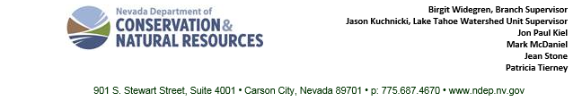
901 S. Stewart Street Suite 4001, Carson City, NV 89701 775.687.9444 www.ndep.nv.gov

Nevada 8-Digit Hydrologic Unit Code(s) & Catalog Name(s)¹:

Additional HUCs
HUC(s) Unknown

1. If more than one HUC applicable, input under “Additional HUCs.” HUCs information may be found at http://water.usgs.gov/GIS/huc.html.
Project Summary (150 word limit):

Fiscal Summary:

319(h) funds requested $
Total amount of non-federal match² funds $
Total Project Cost $
2. Cash + Inkind: Must be at least 50% of Total Project Cost

Anticipated Project Start Date: Click or tap to enter a date.
Anticipated Project Completion Date: Click here to enter a date.
Name of applicable Watershed Plan and/or TMDL:

Note: A “No” response may result in an Initial Determination of Ineligibility.

Is the State’s Standard Contract Language acceptable to applicant?
Yes No N/A

Is the applicant able to pay for costs up front, and be subsequently reimbursed by the State (No grant advances are provided)?
Yes No N/A

Does the project budget include at least 50 percent³ non-federal match?
3. Local match must be at least 50% of total project cost. 319(h) funds cannot exceed 50% of total project cost.

Yes No N/A

Does the project include plans for monitoring and maintenance?
Yes No N/A

Will timelines for required permits be included in the Project’s Schedule?
Yes No N/A

Is the project identified or otherwise covered under an approved Watershed Based Plan or TMDL?
Yes No N/A

N/A Explanations:

For Agency Use Only:

Related Proposal No. 319-2019-1
Received by: Reviewed by:

Date Received: Click or tap to enter a date.

Initial Determination of Eligibility:
Eligible
Ineligible

Additional information required to make determination:
Yes
No

Request for Additional Information, Date: Click or tap to enter a date.
Notice of Determination, Date: Click or tap to enter a date.

