Nevada Division of Environmental Protection
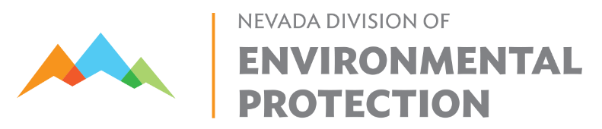
Bureau of Safe Drinking Water
901 S. Stewart Street, Suite 4001
Carson City, Nevada 89701
Sanitary Survey Response Form
In accordance with Nevada Administrative Code 445A.4665, “Any significant deficiency noted in a sanitary survey must be addressed in writing to the Division or to the appropriate district board of health and must include a proposed implementation plan and schedule for correction of the deficiency within 45 days after the receipt of the sanitary survey report by the public water system.”
Please note that this form is intended to help water systems respond to sanitary survey findings but use of the form is not required. Suppliers of water can provide responses using a different format if all of the required information is included. Water systems may also request an electronic copy of this form. Please provide documentation of any corrective actions taken (i.e., monitoring plan submitted on 1/2/2022, mesh screen photo is attached, etc.)
System and Sanitary Survey Information
System Name
PWS ID
Date of Sanitary Survey Letter
Primary Inspector Name
Public Water System Response
Representative Name and Affiliation
Representative Phone Number/Email
Response Date

Description of deficiency | Describe the corrective action(s) taken or corrective action(s) that your system plans to take
 |  | Date Resolved/Proposed:
 |  | Pictures Included (Y/N):
 |  | Date Resolved/Proposed:
 |  | Pictures Included (Y/N):
 |  | Date Resolved/Proposed:
 |  | Pictures Included (Y/N):

