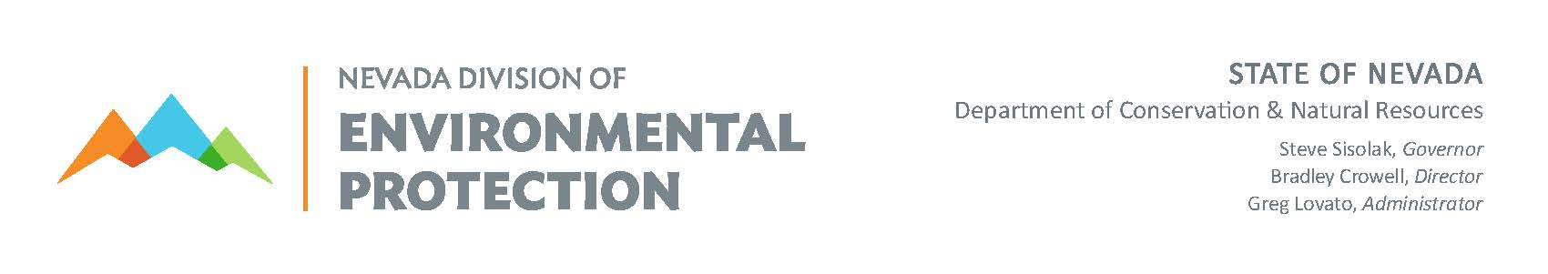

BUREAU OF SAFE DRINKING WATER
PUBLIC WATER SYSTEM NAME / ADDRESS UPDATE FORM

PWS NAME: * PWS ID: * PHYSICAL ADDRESS: *
MAILING ADDRESS: *
CITY: * STATE: * ZIP: *
PWS NAME CHANGE TO:
PRIMARY CONTACT (All correspondence will be directed to this individual):
NAME: TELEPHONE: MAILING ADDRESS: EMERGENCY PHONE: CITY: STATE: ZIP: CELL PHONE:
E‐MAIL:

OWNER CONTACT: TELEPHONE: MAILING ADDRESS: EMERGENCY PHONE:
CITY: STATE: ZIP: CELL PHONE:
E‐MAIL:
IF OWNER IS A COMPANY, REPRESENTATIVE MUST BE AN INDIVIDUAL
OWNER REPRESENTATIVE: TELEPHONE: MAILING ADDRESS: EMERGENCY PHONE:
CITY: STATE: ZIP: CELL PHONE:
E‐MAIL:

OPERATOR IN RESPONSIBLE CHARGE (Monitoring and Violation info will also be directed to this individual): NAME: OP ID #: CERTIFICATION LEVEL:
NV CERTIFIED OPERATOR: ? YES  NO  SAME AS PRIMARY CONTACT: 
MAILING ADDRESS: TELEPHONE: CITY: STATE: ZIP: EMERGENCY PHONE: E‐MAIL: CELL PHONE:

SECONDARY – EMERGENCY CONTACT: TELEPHONE:
MAILING ADDRESS: EMERGENCY PHONE: CITY: STATE: ZIP: CELL PHONE:
E‐MAIL: NOTE: FOR ADDITIONAL OPERATORS INCLUDE SEPARATE SHEET

PERMIT FEE CONTACT: SAME AS PRIMARY CONTACT: 
MAILING ADDRESS: TELEPHONE: CITY: STATE: ZIP: EMERGENCY PHONE: E‐MAIL: CELL PHONE:

*REQUIRED FIELD Carson City, NV 89701
Please return this form to: | Nevada Division of Environmental Protection | Fax #: | 775‐687‐5699
 | Bureau of Safe Drinking Water | Email: | E‐Data_BSDW@ndep.nv.gov
 | 901 S Stewart Street, Suite 4001 | Telephone: | 775‐687‐9521

