Class II General Air Quality Operating Permit for Concrete Batch Plants
Application Form

Facility Name: Click or tap here to enter text.
Existing Facility ID: AClick or tap here to enter text.
Existing Class II General AQOP for Concrete Batch Plants:
APClick or tap here to enter text.

Application Type:
☐ New Class II General AQOP for Concrete Batch Plants
☐ Revision of Existing Class II General AQOP for Concrete Batch Plants
☐ Renewal of Existing Class II General AQOP for Concrete Batch Plants

Please Submit Application to:
Nevada Division of Environmental Protection
Bureau of Air Pollution Control, Class II Permitting Branch
901 South Stewart Street, Suite 4001
Carson City, Nevada 89701-5249
Phone (775) 687-9349

August 2022

Important Information

- The application packet contains:
  - General Company Information Form
  - Application Fee
  - Special Use Area Additional Information Forms (if applicable)
  - Emission Factors
  - Emission Limits
  - Emission Calculation Form(s)
  - Surface Area Disturbance Form
  - Application Certification Document with Required Attachments
  - Process Narrative
  - Process Flow Diagram(s)
  - Location Map(s)

- Please see the Guidance Document for additional instructions on how to complete the application.
- A printed copy of the application must be submitted (mailed or hand delivered), along with an electronic version.
- The application filing fee required by Nevada Administrative Code (NAC) 445B.327 must be submitted with the completed application. Checks must be made payable to the “Nevada State Treasurer, Environmental Protection” with “BAPC” noted in the memo line. Fees may also be submitted electronically at https://epayments.ndep.nv.gov/.
- This application shall be used for new Class II General sources (Concrete Batch Plants), revisions to existing Class II General Air Quality Operating Permits for Concrete Batch Plants, and the renewal of Class II General Air Quality Operating Permits for Concrete Batch Plants. This application packet is not to be used for an Administrative Amendment, Class II Air Quality Operating Permits, a stand-alone Surface Area Disturbance (SAD) permit, nor for a Request for Change of Location Approval permit for a temporary source.
- An application for a Class II General Air Quality Operating Permit for Concrete Batch Plants must be signed by the Responsible Official, as defined in NAC 445B.156. The certification/signature page is the last page of the application and the original “wet” signature must be provided.
- All items in the application must be addressed. If an item does not apply “N/A” or similar notation must be entered in the appropriate blank. All other information must be provided. Incomplete applications will be returned to the Responsible Official within 10 working days of receipt of the application.
- For the renewal of a Class II General Air Quality Operating Permit for Concrete Batch Plants, a complete application and corresponding filing fee must be submitted in accordance with NAC 445B.3477(12), at least 30 days prior to the expiration date of the current permit. The Nevada Division of Environmental Protection – Bureau of Air Pollution Control (BAPC) suggests that the application be submitted well in advance of the timeline outlined in NAC 445B.3477(12) to ensure the application is deemed complete.
- Please note that the use of engines is not allowed under the Class II General Air Quality Operating Permit for Concrete Batch Plants. Power to operate any emission unit(s) must be provided by line power or other non-emission generating sources.
General Company Information Form

1. Company Name and Address that are to appear on the operating permit
[NAC 445B.295(1)]:

Name:
Address:
City:
State: |  | Zip Code:

2. Owner's Name and Address [NAC 445B.295(1)]:

Name:
Address:
City:
State: |  |  | Zip Code:
E-mail Address:

3. Facility Name and Address, if different from #2 [NAC 445B.295(1)]:

Name:
Address:
City:
State: |  | Zip Code:

4. If records are required under the operating permit will be kept at a location other than the facility, specify that location [NAC 445B.295(7)]:

Name:
Address:
City:
State: |  | Zip Code:

General Company Information Form (continued)

5. Responsible Official Name, Title and Mailing Address [NAC 445B.295(1)]:

Name:
Title:
Address:
City:
State: |  | Zip Code:
Phone Number: | (xxx) xxx-xxxx
Fax Number: | (xxx) xxx-xxxx
E-mail Address:

6. Plant Manager or other appropriate Contact Name, Title and Address [NAC 445B.295(1)]:

Name:
Title:
Address:
City:
State: |  | Zip Code:
Phone Number: | (xxx) xxx-xxxx
Fax Number: | (xxx) xxx-xxxx
E-mail Address:

7. Location and Driving Directions to the Facility (For Example: From Elko, Nevada, 4 miles south of I-80 at xx Interchange) [NAC 445B.295(8)]:

Township(s): |  | N; | Range(s): |  | E; | Section(s):
UTM Coordinates for the Front Gate of the Facility (NAD 83, Zone 11):
 |  | m North; |  |  | m East;
Nearest City:
County:
Hydrographic Area:
Driving Directions from nearest city to the Facility:

8. What is the minimum setback of equipment from public access and maximum hours of operation?

Minimum Setback: | Maximum Hours of Operation:
☐ 5 meters  ☐ 10 meters  ☐ 25 meters  ☐ 50 meters  ☐ 75 meters  ☐ 100 meters | ☐ 8 hrs  ☐ 12 hrs  ☐ 16 hrs  ☐ 24 hrs

CLASS II GENERAL PERMIT SPECIAL USE AREA

Under the authority of NAC 445B.22097, the following exceptions and additional requirements apply to applicants applying for this Class II General Air Quality Operating Permit for Concrete Batch Plants:
1. For stationary sources applying to operate under this general permit in the Class II General Special Use Area described in this section, the following constraints apply:
a. The Director will require a 30-day time period to conduct an Environmental Evaluation to demonstrate compliance with the Nevada Ambient Air Quality Standards (NAAQS) for any regulated air pollutant.
b. If compliance with the NAAQS for any regulated air pollutant cannot be demonstrated under the requirements of the Class II General Air Quality Operating Permit for Concrete Batch Plants, authorization to operate will not be approved. A Class II Air Quality Operating Permit must be applied for and approved prior to operation.
2. Tracy Segment – Hydrographic Area (HA) 83

Township | Range | Sections
19 North | 21 East | 1, 2, 10 through 14, and 23 through 25
19 North | 22 East | All Sections
19 North | 23 East | 3 through 10, 16 through 21, and 29 through 31
20 North | 22 East | 24 through 26, 28, 29, and 31 through 36
20 North | 23 East | 19 through 21, and 27 through 34
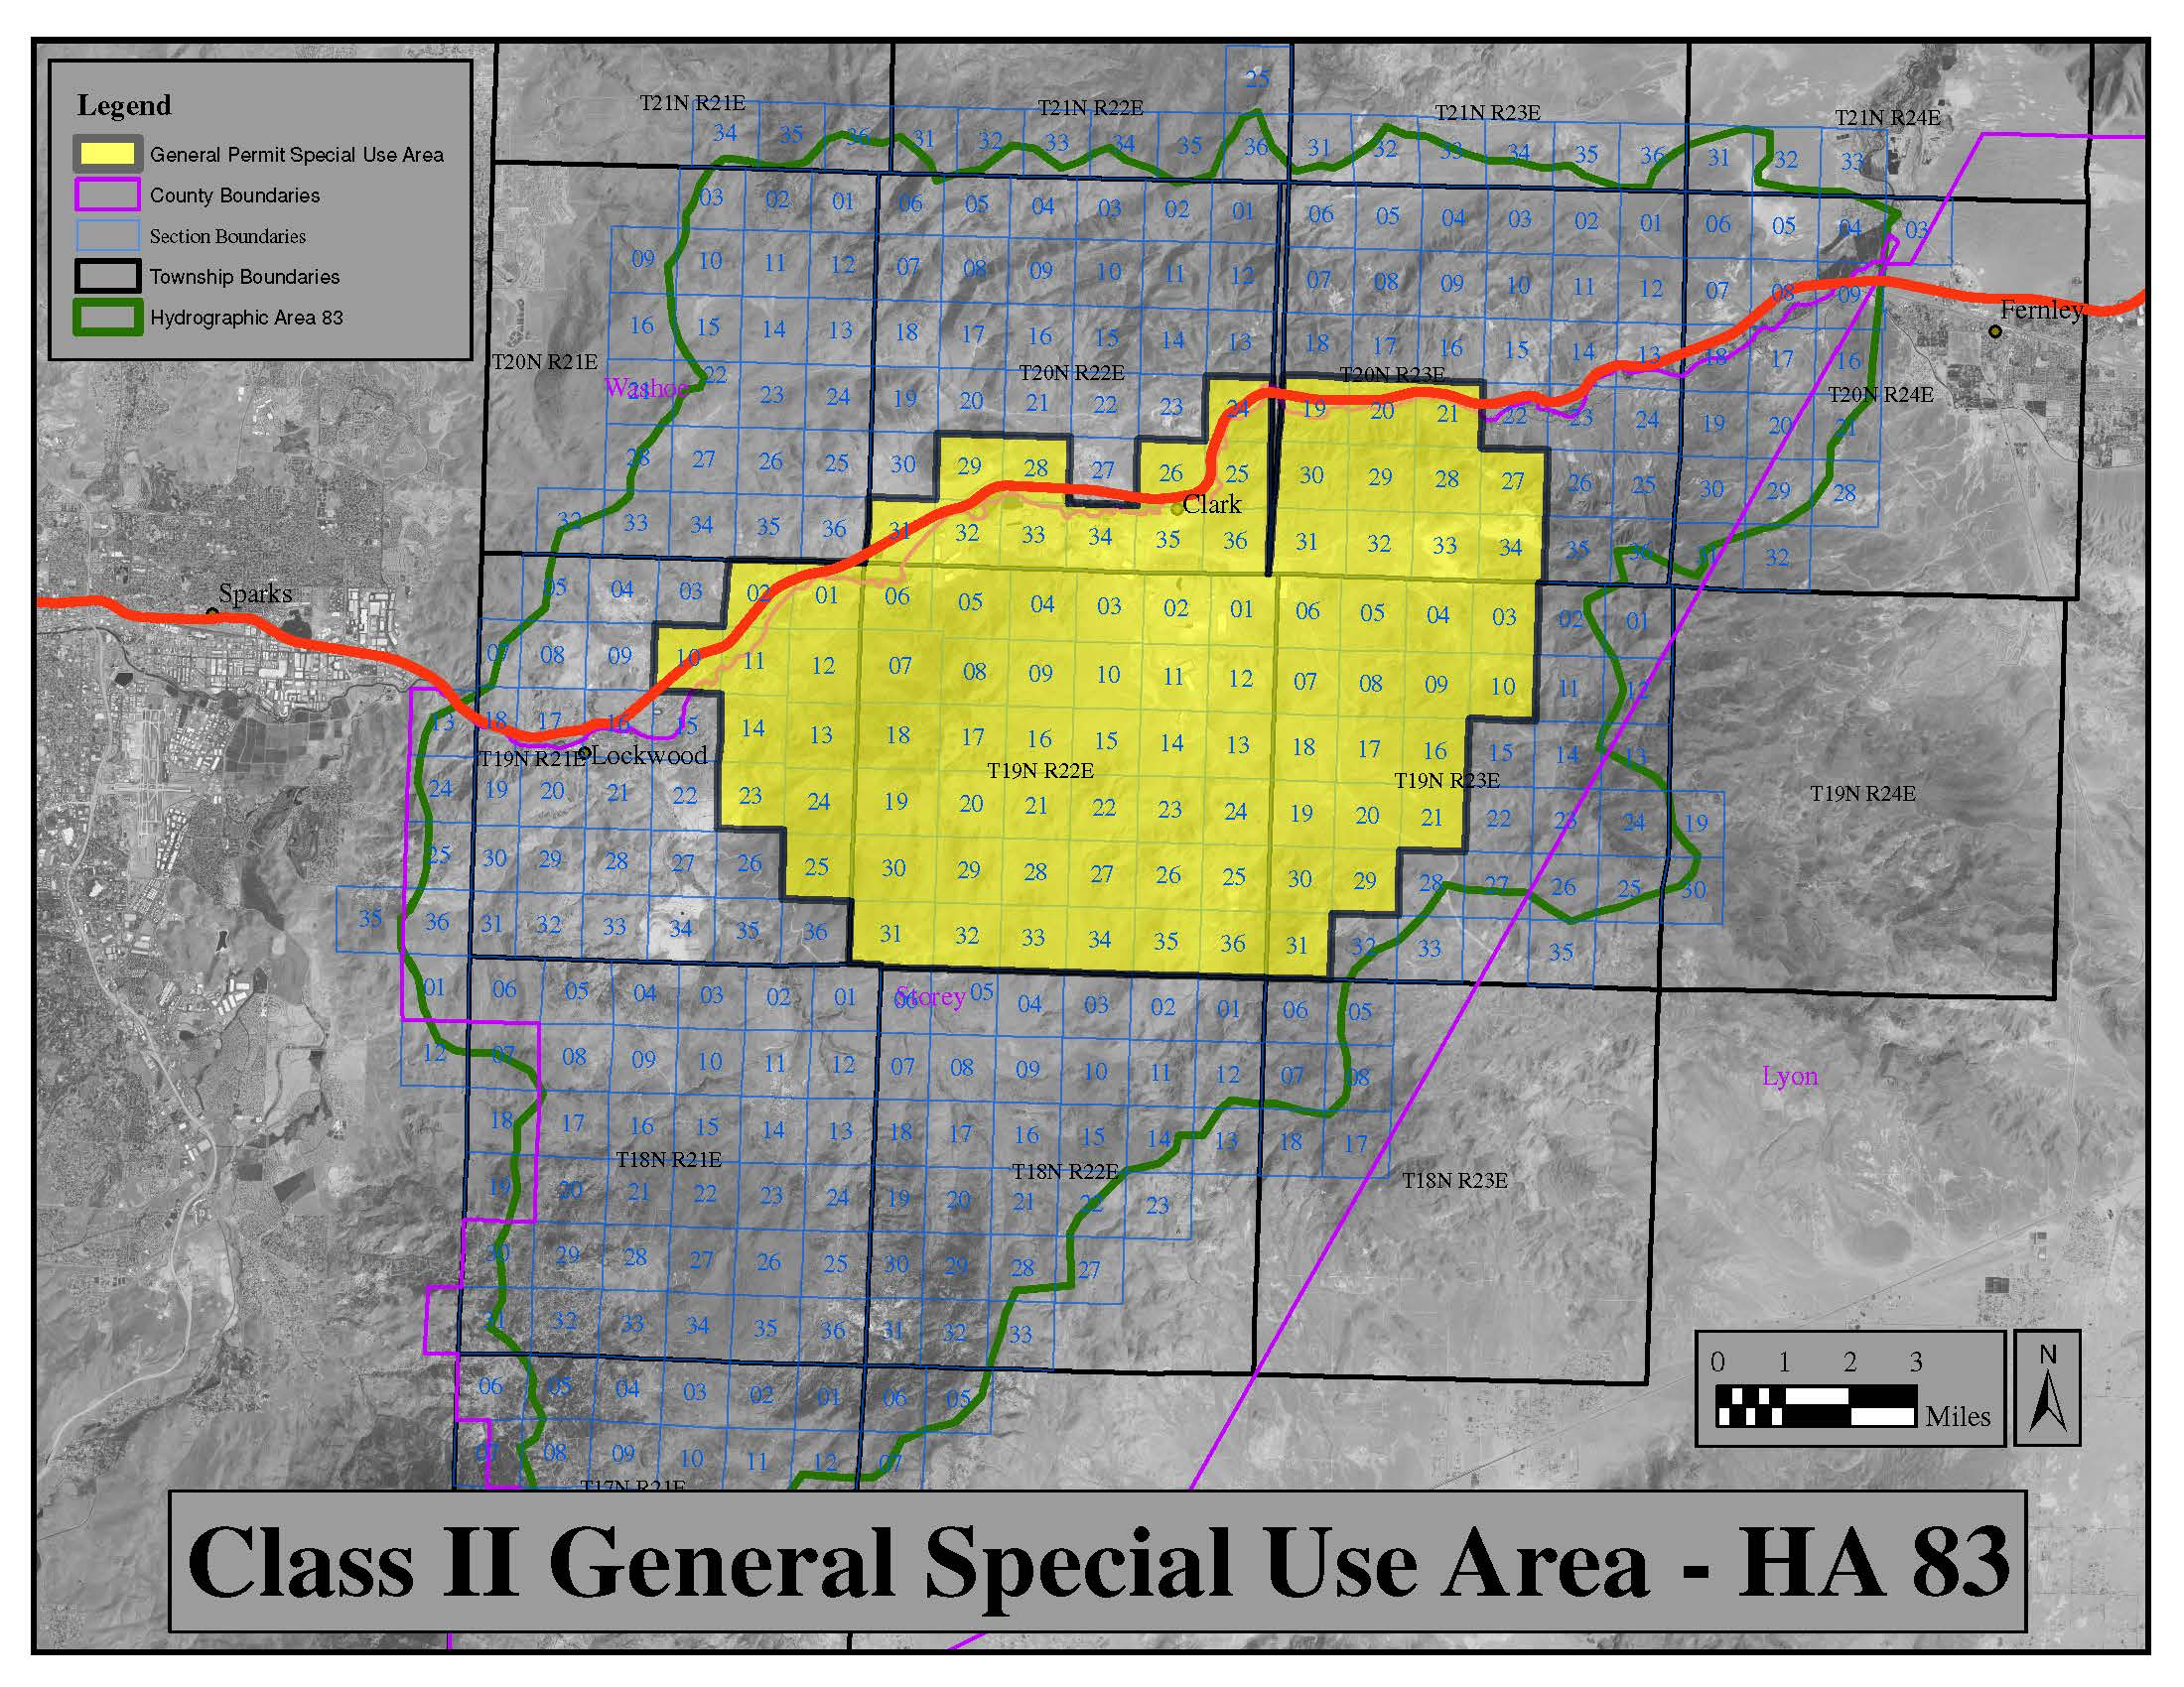
EMISSION FACTORS

Under the authority of NAC 445B.305, the emission factors listed below are to be used to calculate the Potential to Emit (PTE), for operating scenarios authorized by the general permit:

Concrete Batching
Emission Unit | Emission Factor (lb/ton)
 | PM | PM₁₀ | PM_{2.5}
Loader to Feeder or Bin - Water Spray Controlled¹ | 0.00075 | 0.00028 | 0.00004
Loader to Feeder or Bin - Uncontrolled | 0.003 | 0.0011 | 0.00017
Aggregate/Sand Conveyor Transfer Point - Water Spray Controlled¹ | 0.00075 | 0.00028 | 0.00004
Aggregate/Sand Conveyor Transfer Point - Enclosure Controlled⁴ | 0.00150 | 0.00055 | 0.00009
Aggregate/Sand Conveyor Transfer Point - Uncontrolled | 0.003 | 0.0011 | 0.00017
Cement Silo Loading - Controlled² | 0.00099 | 0.00034 | 0.00005
Cement Silo Unloading - Uncontrolled | 0.0048 | 0.0028 | 0.0004
Cement Silo Unloading - Enclosure Controlled⁴ | 0.0024 | 0.0014 | 0.0002
Weigh Hopper Loading - Uncontrolled | 0.0048 | 0.0028 | 0.0004
Weigh Hopper Loading - Enclosure Controlled⁴ | 0.0024 | 0.0014 | 0.0002
Cement Supplement Silo Loading - Controlled² | 0.0089 | 0.0049 | 0.0007
Cement Supplement Silo Unloading - Uncontrolled | 0.0048 | 0.0028 | 0.0004
Central Mixer Loading - Controlled³ | 0.0184 | 0.0055 | 0.0008
Central Mixer Loading - Uncontrolled | 0.572 | 0.156 | 0.024
Truck Mixer Loading - Controlled³ | 0.098 | 0.0263 | 0.004
Truck Mixer Loading - Uncontrolled | 1.118 | 0.31 | 0.047
Notes:
- The emission factors listed for controlled emissions require wet dust suppression located at each emission unit and transfer point. Wet dust suppression consists of water sprays, fogging water sprays, fogging water sprays with chemical surfactant, or pneumatic fogging water sprays. Pre-wetting of material does not constitute wet dust suppression. Uncontrolled emission units are not permitted for nonmetallic mineral processing. No uncontrolled emission factors available.
- Emissions during loading are controlled by a bin vent or baghouse
- Installations that employ water sprays, enclosures, hoods, curtains, shrouds, moveable and telescoping chutes, and central duct collection systems.
- The emission factors listed for controlled emissions require the use of an enclosure at the transfer point. An enclosure must have a solid cover surrounding the transfer point. This excludes entries and exits. Transfer points must not be clearly visible.

Heater
Emission Unit | Emission Factor (lb/hr)
 | PM | PM₁₀ | PM_{2.5} | NO_{x} | SO₂ | CO | VOC
Natural Gas Heater Equal to or Less Than 3.98 MMBtu/hr | 0.030 | 0.030 | 0.030 | 0.391 | 0.0023 | 0.328 | 0.021
Propane Heater Equal to or Less Than 3.98 MMBtu/hr | 0.031 | 0.031 | 0.031 | 0.566 | 0.065 | 0.326 | 0.043

EMISSION LIMITS

Under the authority of NAC 445B.305, NAC 445B.22017, and NAC 445B.346, the calculated emissions at any one location shall not equal or exceed any of the emission limits specified in the table below:

Operating Scenario | Operating Parameters |  | Emission Limits (lb/day)
 | Minimum Setback (meters) | Maximum Daily Hours of Operation | PM₁₀ | PM_{2.5}
Concrete batch plants (may include aggregate/sand hopper/bin loading/unloading and associated conveyor transfers, cement/cement supplement silo loading/unloading, mixer loading, including 2.75 MMBtu propane heater or a 3.98 MMBtu natural gas heater) | 5 | 8 | 8.96 | 1.57
 |  | 12 | 10.69 | 1.93
 |  | 16 | 12.00 | 2.24
 |  | 24 | 13.84 | 2.73
 | 10 | 8 | 9.96 | 1.72
 |  | 12 | 11.95 | 2.12
 |  | 16 | 13.31 | 2.44
 |  | 24 | 15.11 | 2.92
 | 25 | 8 | 11.69 | 1.98
 |  | 12 | 13.26 | 2.32
 |  | 16 | 14.93 | 2.68
 |  | 24 | 16.81 | 3.18
 | 50 | 8 | 17.80 | 2.90
 |  | 12 | 20.32 | 3.39
 |  | 16 | 22.61 | 3.84
 |  | 24 | 23.34 | 4.16
 | 75 | 8 | 25.38 | 4.05
 |  | 12 | 29.28 | 4.75
 |  | 16 | 31.40 | 5.17
 |  | 24 | 33.10 | 5.64
 | 100 | 8 | 32.33 | 5.10
 |  | 12 | 38.18 | 6.09
 |  | 16 | 41.62 | 6.72
 |  | 24 | 44.31 | 7.34

Note: PM emissions should be calculated using the emission factors prescribed on page 7 of this application; however, since there are no Nevada Ambient Air Quality standards for PM, there will be no emission limits for PM emissions.

Form 1A – Emission Unit List: Particulate Emissions (PM) Units Calculation Form³
[Use this table or equivalent spreadsheet to request operating parameters and calculated particulate emissions for each emission unit.]

Emission Unit Description | Material Process Rate |  | Operating Hours (hrs/day) | Emissions Control Technology | Emission Factor¹ |  |  | Calculated PM Emissions (lbs/day) | Calculated PM₁₀ Emissions (lbs/day) | Calculated PM_{2.5} Emissions (lbs/day)
 | tons/  hr | tons/  project |  |  | PM  (lbs/ton) | PM₁₀  (lbs/ton) | PM_{2.5}  (lbs/ton)
Ex. Conveyor 1 to 2 | 500 | 500,000 | 16 | Water Sprays | 0.00014 | 0.000046 | 0.000013 | 1.12 | 0.368 | 0.104
 |  |  |  |  |  |  | Total Emission Limits²
1. The Emission Factors stated in this application must be used.
2. The total of PM₁₀ and PM_{2.5} emissions combined for all units must not exceed limits established for the minimum setback and hours of operation that are being requested.
3. Use additional forms as necessary.
Example Calculation: 500 tons/hr x 16 hr/day x 0.00014 lbs/ton = 1.12 lbs/day

Form 1B – Special Use Area Additional Information¹
[Use Form 1B if applying for a Class II General Air Quality Operating Permit for Concrete Batch Plants in the Special Use Area as described in this application.]

Emission Unit Description | Emission Unit Identifier | UTM Coordinates  (NAD 83, Zone 11) |  | Release Height (ft) | Drop Length (ft) | Emission Unit Dimensions L x W x H  (ft) | Stack Height (ft) | Stack Inside Diameter or L x W Dimensions (ft) | Stack Flow Rate (acfm) | Stack Exit Velocity (ft/sec) | Stack Temperature (°F) | Requested Hours of Operation
 |  | Easting (m) | Northing (m) |  |  |  |  |  |  |  |  | Start Time (AM/PM) | End Time (AM/PM)
1. Use additional forms as necessary.

Form 1C – Special Use Area Additional Information
[Use Form 1C if applying for a Class II General Air Quality Operating Permit for Concrete Batch Plants in the Special Use Area as described in this application. In addition to filling out this form, please provide a topographic map (or similar satellite-image map) showing the entire fence line boundary for the proposed location.]

Corner Number | Corner Location of Fence Line Boundary for the proposed Change of Location
 | UTM Easting (m)  (NAD 83, Zone 11) | UTM Northing (m)  (NAD 83, Zone 11)

Surface Area Disturbance Form

- Project Name: Click or tap here to enter text.
- Total Acres Disturbed: Click or tap here to enter text.
- NAC 445B.22037 requires fugitive dust to be controlled (regardless of the size or amount of acreage disturbed), and requires an ongoing program, using best practical methods, to prevent particulate matter from becoming airborne. All activities which have the potential to adversely affect the local air quality must implement all appropriate measures to limit controllable emissions. Appropriate measures for dust control may consist of a phased approach to acreage disturbance rather than disturbing the entire area all at once; using wet suppression through such application methods as water trucks or water spray systems to control wind-blown dust; the application of soil binding agents or chemical surfactant to roadways and areas of disturbed soil; as well as the use of wind-break or wind limiting fencing designed to limit wind erosion soils.
- Please check each box that applies for Best Management Practices (BMPs) used for controlling dust on project’s disturbed areas:

☐ Water trucks
☐ Graveling/paving of roadway storage areas and staging areas
☐ Dust palliatives
☐ Posting and limiting vehicle speeds
☐ Ceasing operations during high wind events
☐ Fencing or berming to prevent unauthorized access to disturbed areas
☐ Application of water sprays on material storage piles on a regular basis
☐ Covering material storage piles with tarpaulin or geo-textiles; tenting
☐ Use of overhead water spray racks or water hoses
☐ Track-out controls (graveled entranced, exit area, and street sweeping)
☐ Landscape preservation and impact avoidance
☐ Wind fence
☐ Pre-watering of areas to be disturbed (including all unpaved onsite roads and staging areas)
☐ Inform all subcontractors (including truck drivers) of their responsibilities for the control of fugitive dust while they are on the project site
☐ Training of equipment operators to recognize fugitive dust generation and having the authority to shut down operations until water truck arrives and sprays water on the disturbed areas
☐ Other Applicable BMPs: Click or tap here to enter text.
☐ Other Applicable BMPs: Click or tap here to enter text.
☐ If using water trucks, list how many water trucks are used and their capacity in gallons:
Click or tap here to enter text.

APPLICATION CERTIFICATION DOCUMENT
(With Required Attachments)

Please check all applicable boxes below to indicate the information provided in your application submittal:

☐ General Company Information Form
☐ $500 Application Fee Attached (NAC 445B.327)
☐ $500 Application Fee Electronically Submitted (NAC 445B.327)
☐ Form 1A – Particulate Emissions Calculation Form(s)
☐ Form 1B – Special Use Area Form (if applicable)
☐ Form 1C – Special Use Area Form (if applicable)
☐ Surface Area Disturbance Form
☐ Process Flow Diagrams(s) of the emission units as they will be set up, including identification of all pollution control(s) and which emission units are controlled by these devices. All emission units must be identified by name.
☐ Process Narrative which details the flow of material as shown in the Process Flow Diagram(s).
☐ Topographic Map (or similar satellite-image map) indicating the exact location of each emission unit.
☐ Special Use Area Map (topographic map or similar satellite-image map) – showing the entire fence line boundary for the proposed location (if applicable).
☐ Application Certification Document with Original “Wet” Signature from the Responsible Official

PLEASE NOTE THE FOLLOWING REQUIREMENTS WHICH APPLY TO APPLICANTS DURING THE APPLICATION PROCESS:

- A permit applicant must submit supplementary facts or corrected information upon discovery [NAC 445B.297(1)(b)].
- A permit applicant is required to provide any additional information which the Director requests in writing within the time specified in the Director's request [NAC 445B.297(1)(c)].
C. Submission of fraudulent data or other information may result in prosecution for an alleged criminal offense [NRS 445B.470].

CERTIFICATION:

I certify that, based on information and belief formed after reasonable inquiry, the statements and information contained in this application are true, accurate and complete.

Signature of Responsible Official
Print or Type Name and Title
Date

