Bureau of Safe Drinking Water

CMDP Data Submission Guide – Total Coliform/E. coli and Residual Chlorine Concentration
Document Instructions
The Excel template used for reporting Total Coliform (TC) and E. coli (EC) samples for RTCR and residual chlorine concentrations (if applicable) is separated into three sections: Sample Information, Results, and Field Results and Measurements.
Submit the information as described on the following pages for TC/EC samples and distribution chlorine. This guidance document will highlight the required fields within each section.
Header fields in RED and underlined text are required in order to meet federal and state reporting requirements.
Header fields in BLUE and underlined text are conditionally or situationally required.
Header fields in BLACK text are not required for a successful data submission.
Samples will be rejected if the required fields are left blank.
Additionally, keep in mind:
- Use drop down icons to filter data.
- If you have questions, please contact our CMDP support staff at E-Data_BSDW@ndep.nv.gov.
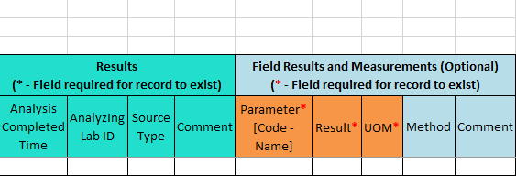
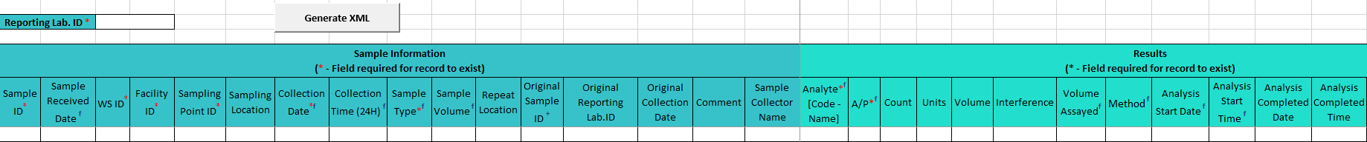
Section 3: Field Results and Measurements
Section 2: Microbial Results
Section 1: Sample Information

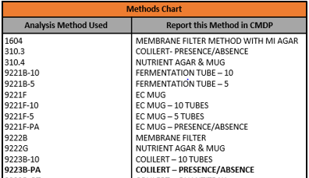
Methods Chart: Page 3

Section 1: Sample Information
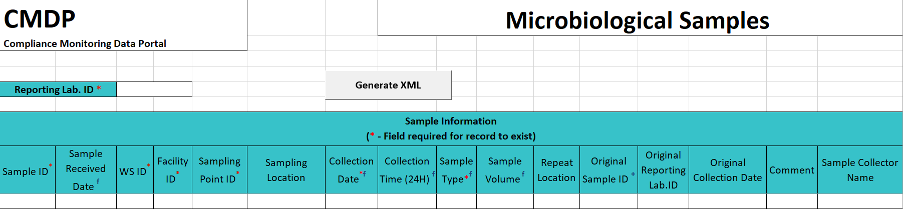

Reporting Lab ID: Lab identification number.
Sample ID: Lab sample identification number, limit to 20 characters (numbers, letters, dashes, and underscores are allowed).
Sample Received Date: Date sample was received by lab (MM/DD/YY).
WS ID: Public Water System identification number (PWSID).
NOTE: Each water system name has a unique PWS ID number. If the name and number on the work order does not match what is listed in CMDP, contact E-Data_BSDW@ndep.nv.gov or 775-687-9521 for help.

Facility ID: Select the appropriate water system facility from where the sample was collected.
Sampling Point ID: Select the appropriate sample point related to the facility where the sample was collected.
If you are unsure of the Facility ID and Sampling Point ID to enter, refer to either:
- Drinking Water Watch: https://ndwis.ndep.nv.gov/DWW/
- CMDP Water System Facility/Sample Point List, which provides the appropriate Facility ID and Sample Point ID for each analyte sampled for an individual public water system.

Sampling Location: This field must describe the location where the sample was taken from in the distribution system (i.e., 123 Main Street, Health Clinic, Kitchen sink, etc.). Keep description succinct (numbers, letters, dash/underscore (-_) only).
Collection Date: Date sample collected (MM/DD/YY).
Collection Time (24H): Time sample collected (HH:MM).
Sample Type: From the drop down menu, select the appropriate sample type (routine, repeat, special, triggered, etc.).
If you are submitting a sample that is Not for Compliance, select Special from the Sample Type drop down menu.
If you are submitting a seasonal startup sample, select Special from the Sample Type drop down menu.

Sample Volume: Volume of sample analyzed (numerical value only).
Repeat Location: Not required, but report if information is available.
Original Sample ID: If reporting a Repeat or Triggered sample, enter the lab Sample ID of the original TC+ sample that caused the repeat or triggered sample(s) to be collected.
Original Reporting Lab ID: Not required, but report if information is available.
Original Collection Date: Not required, but report if information is available (MM/DD/YY).
Comment: Comments are optional.
Sample Collector Name: Name of sample collector.
Section 2: Results
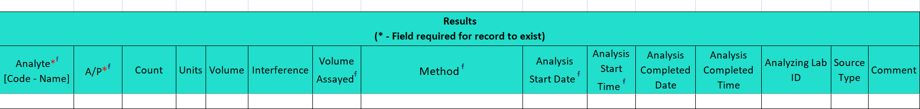

Analyte [Code-Name]: From the drop down menu (pictured below), select either 3100 Coliform (TCR) or 3014 E. coli as appropriate.
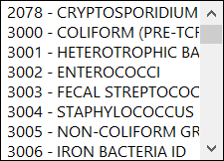

A/P: From the drop down menu, select whether the contaminant was Absent or Present in the analyzed sample.
Count: Count of TC+ or EC+ sample. Enter the count only if required by analysis method.
Units: From the drop down menu, select the unit of measure for the sample result as appropriate.
Volume: Volume of sample. Enter the appropriate volume of the TC+/EC+ sample only if required by the analysis method.
Interference: Not required but report if applicable.
Volume Assayed: Volume of sample analyzed (numerical value only).

Method: This drop down list includes methods for ALL microbial analyses and is not filtered by the analytes your lab (or subcontracting lab) is certified for. Be sure to verify certification status and select the appropriate method listed in the Methods Chart (shown to the right). Notice that each Analysis Method Used by labs is assigned to a specific reporting code indicated in the Report this Method in CMDP column. Samples will be rejected if users report a code that is not listed on the methods chart. (The most commonly used method is 9223B-PA).
Analysis Start Date: Date when lab began analysis (MM/DD/YY).
Analysis Start Time: Time when lab began analysis (HH:MM).
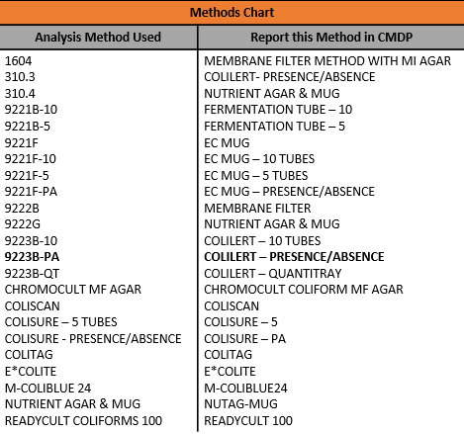

Analysis Completed Date: Not required but report if information is available (MM/DD/YY).
Analysis Completed Time: Not required but report if information is available (HH:MM).
Analyzing Lab ID: If the sample was subcontracted to a different lab for analysis, the analyzing lab identification number is required to be reported here.
Source Type: Not required but report if information is available.
Comment: Not required.
Section 3: Field Results and Measurements (Residual Chlorine Concentrations)
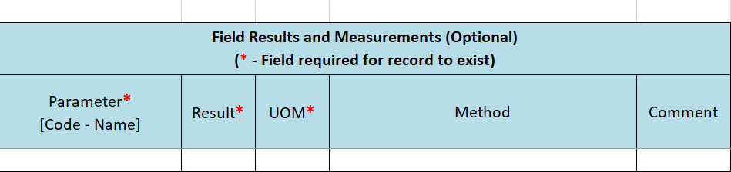

Parameter [Code-Name]: From the drop down menu (pictured below), select the appropriate parameter analyzed, either 1013-FreeChlorineResidual or 1012-TotalChlorineResidual depending on what is noted on the COC. If the type is not noted on the COC, use the Free Chlorine Residual.
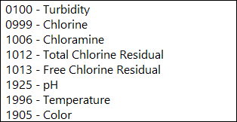

Result: Enter the numerical value of the field result/measurement.
Result UOM: From the drop down menu (pictured below), select the appropriate unit of measurement (mg/L) for the parameter.
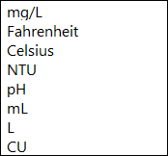

Method: Do NOT report data in this field.
Comment: Not required.

Section 4: Examples of Completed Sample Submissions

Sample Information:

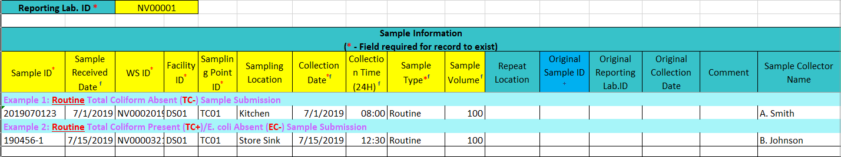

Examples of a Sample Result (Present/Absent):

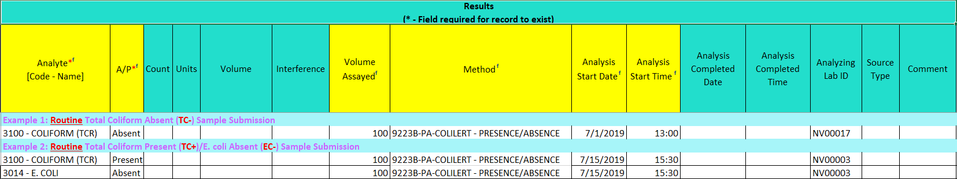

Field Results and Measurements:
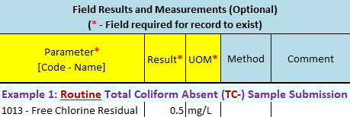

Sample Information:

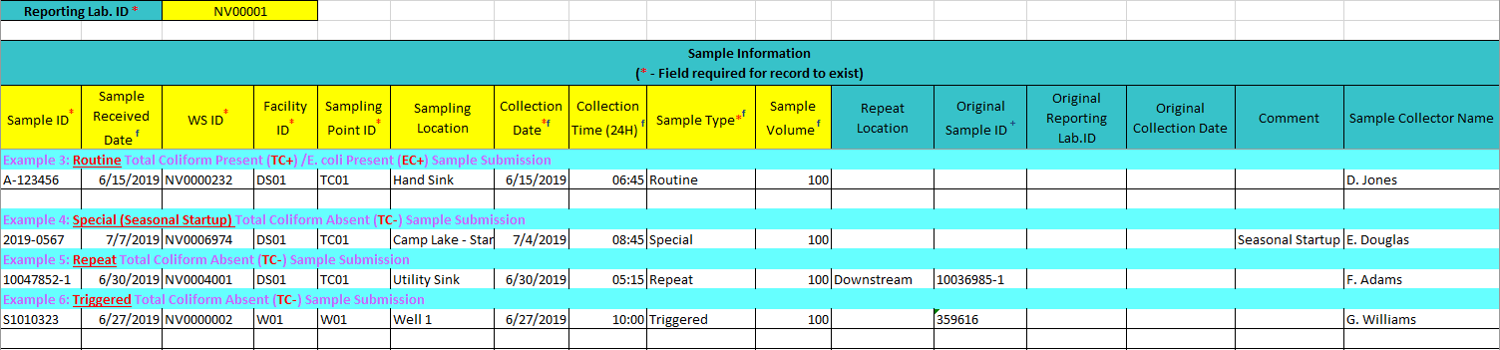

Examples of a Sample Result (Present/Special/Repeat/Triggered):

